|  |  |
| --- | --- |
| TEAM Contact Person: Sergiy Povolyashko [Sergiy.Povolyashko@teaminternational.com](mailto:Sergiy.Povolyashko@teaminternational.com) |  |
| Author: Lyuba Gerasymchuk |  |
| Date: July 05, 2017 |  |





HR Tools Project Guideline

Contents

Document Version 3

Access levels 4

1. Super Admin Role. 5

1.1. Super Admin Role. Review and Manage Companies. 5

1.2. Super Admin Role. How to select/cancel modules. 6

1.3. Super Admin Role. Other functions. 7

2. Admin Role. 8

2.1. Admin Roles. How to select/cancel modules. 8

2.2. Admin Roles. How to Add/Delete Job Titles. 9

2.4. Admin Roles. How to Add User. 11

2.5. Admin Roles. How to Add Employee 12

2.6. Admin Roles. How to create Projects. 14

2.7. Admin Roles. How to create Department. 15

3. User Role. Manager. 16

3.1. Public. Assign Employees to Projects/Department. 16

4. User Role. Employee. 17

4.1. Public. User Access Level. Employee list. 17

# Document Version

|  |  |  |  |
| --- | --- | --- | --- |
| Version | Date | Description | Author |
| 1.0 | 05-04-2017 | HR Tools Project Guideline | Lyuba Gerasymchuk |
| 1.1 | ##-##-2017 | HR Tools Project Guideline Revised |  |
|  |  |  |  |

This Guideline describes user roles and functionality of HR Tools Project and step-by-step instructions how to use the Project.

HR Tools has 4 pre-defined roles: Super Admin, Admin, Manager, User (Employee). Each role is allowed to perform a set of tasks called Capabilities or Functions.

# Access levels

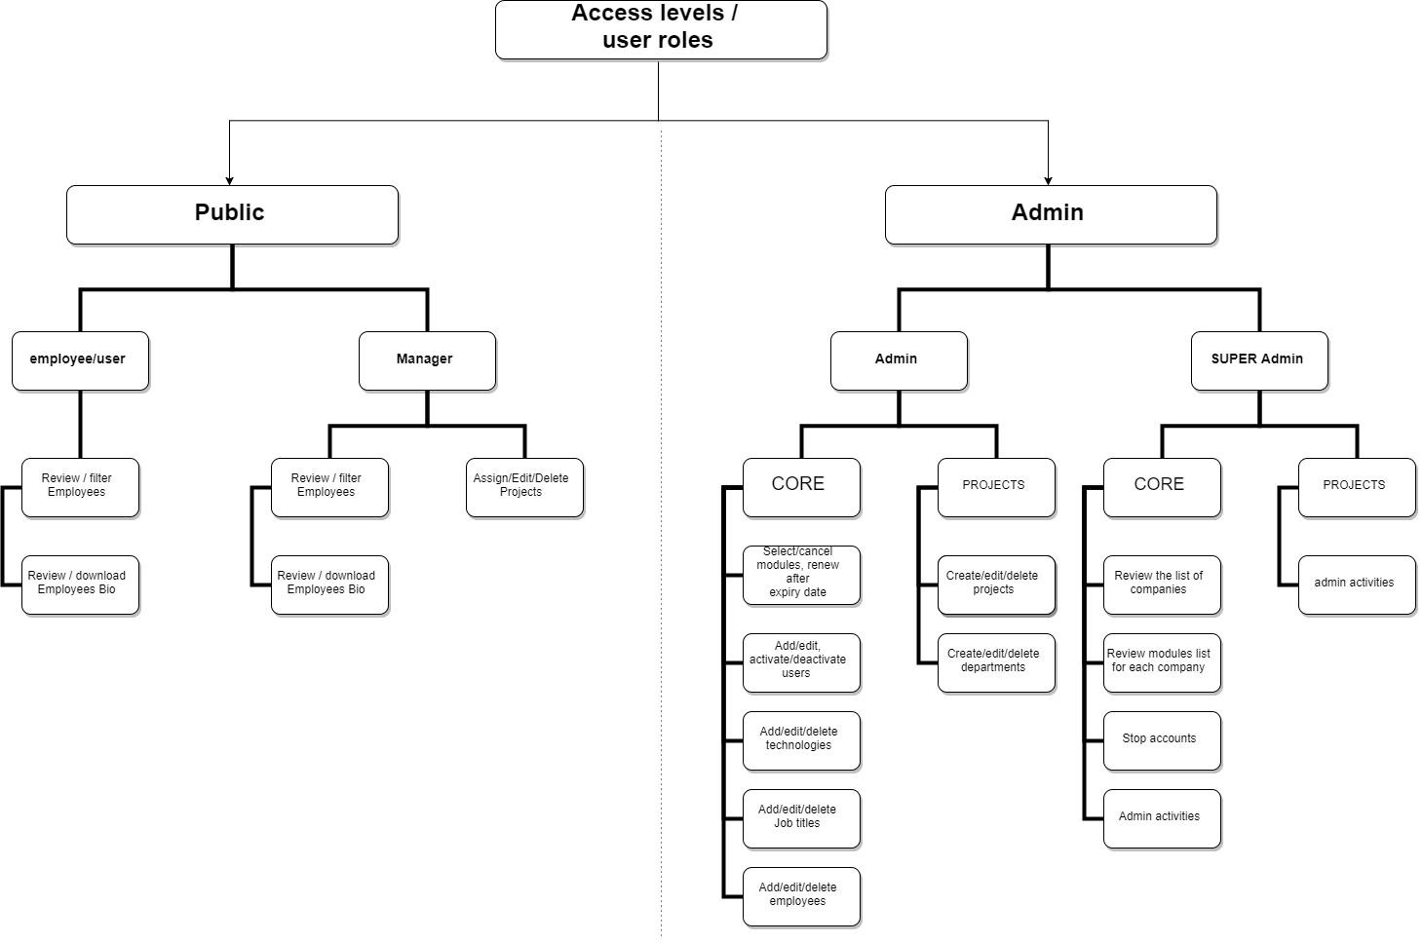

# Super Admin Role.

The Super Admin role allows a user to perform all possible capabilities. Each of the other roles has a decreasing number of allowed capabilities. Super Admin – global root user with access to the System administration features and all other features.

## 1.1. Super Admin Role. Review and Manage Companies.

To Review / Manage Companies enter 'Configuration' section - > Global Modules Configuration.

1. Press on drop-down list on the top of the page to review the lit of Companies. Select one of them to review its Modules.

2. On this page You can Add / Edit or Stop separate modules.

3. To Stop current Account - press 'Stop All' button.

4. To Review / Manage list of Modules for Another Company - select it on drop-down list on the top of the page.

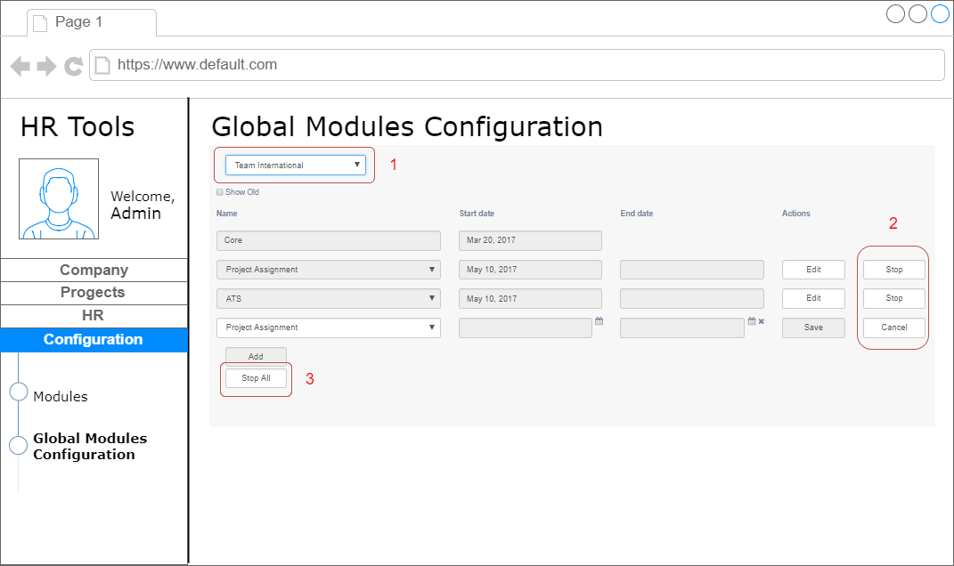

## 1.2. Super Admin Role. How to select/cancel modules.

To select/cancel modules for own Company - enter 'Configuration' - > Modules

1. Press 'Add' Button to add new module.

2. Select Start and End date.

3. To cancel previous action - press 'Cancel'.

4. To stop active module press 'Stop'.

5. Admin can renew modules after expiry date. It is not possible to have two similar modules simultaneously. The module won't be added.

6. It's impossible to edit start date for module, if it is less than current.

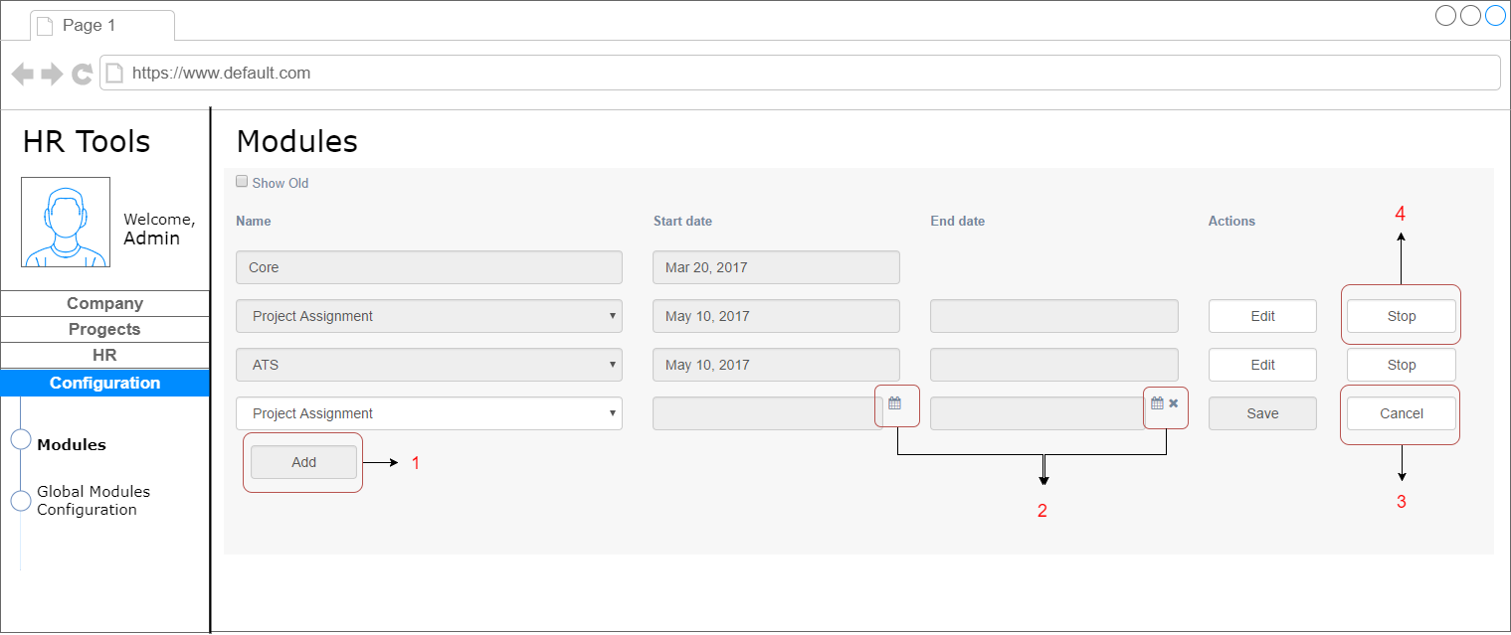

## 1.3. Super Admin Role. Other functions.

Super admin is allowed to perform all functions allowed to Admin. ‘How to’ steps are the same as described in Admin Section. Please see next chapter.

# Admin Role.

Admin is somebody who has access to all the administration features within a single Company.

## 2.1. Admin Roles. How to select/cancel modules.

To select/cancel modules - enter 'Configuration' - > Modules.

1. Press 'Add' Button to add new module.

2. Select Start and End date.

3. To cancel previous action - press 'Cancel'.

4. To stop active module press 'Stop'.

5. Admin can renew modules after expiry date. It is not possible to have two similar modules simultaneously. Module won't be added.

6. It's impossible to edit start date for module, if it is less than current.

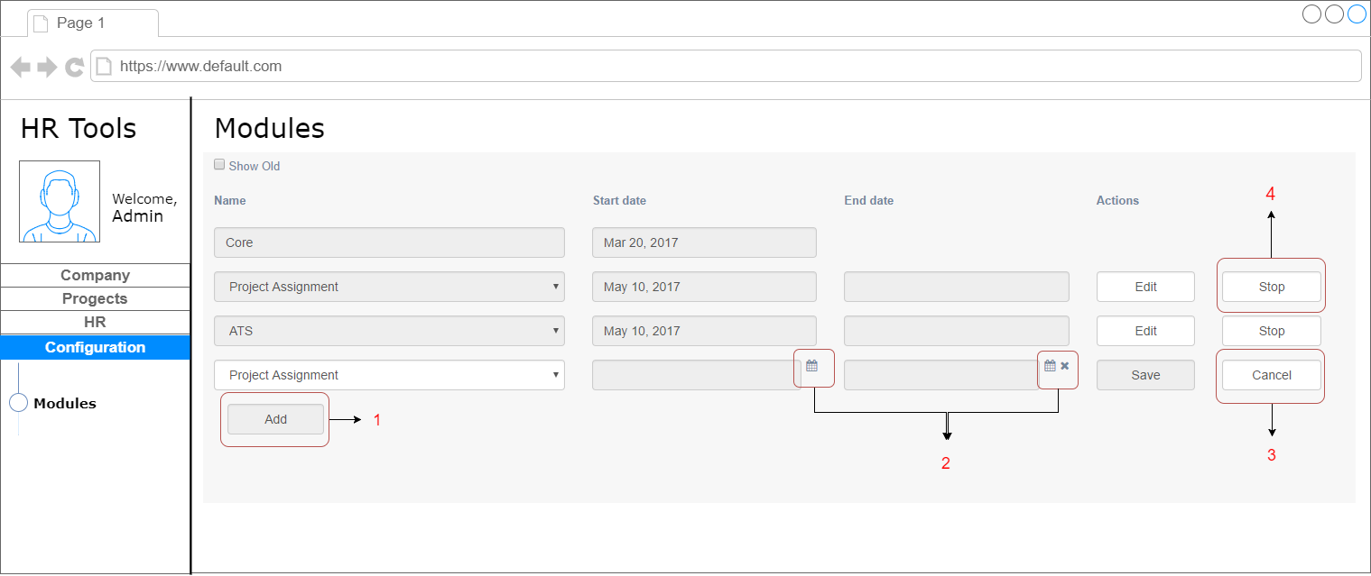

## 2.2. Admin Roles. How to Add/Delete Job Titles.

To add/delete Job Titles - enter 'Company' - > Job Titles.

1. Press 'Add' Button to add new Job Title.

2. To save - press 'Save' to cancel previous action - press 'Cancel'.

3. To remove Job Title - press 'Delete'.

Also, you can Edit existed Job Titles - press 'Edit' button.

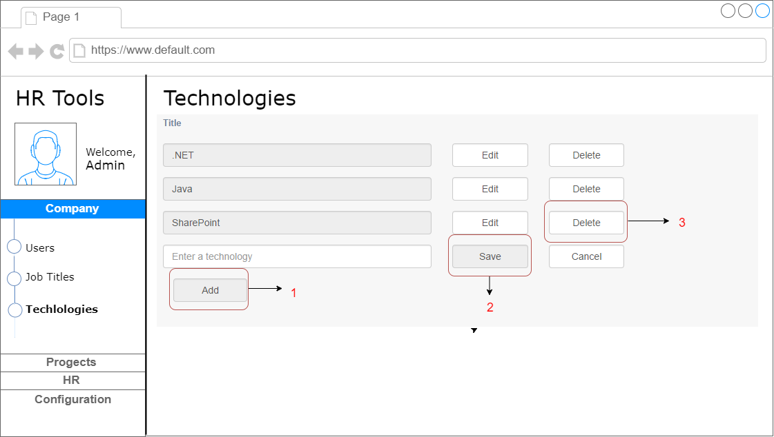2.3 Admin Roles. How to Add/Delete Technologies.

To add/delete Technologies - enter 'Company' - > Technologies.

1. Press 'Add' Button to add new Technology.

2. To save - press 'Save' to cancel previous action - press 'Cancel'.

3. To remove Technology - press 'Delete'.

Also, you can Edit existed Technologies- press 'Edit' button.

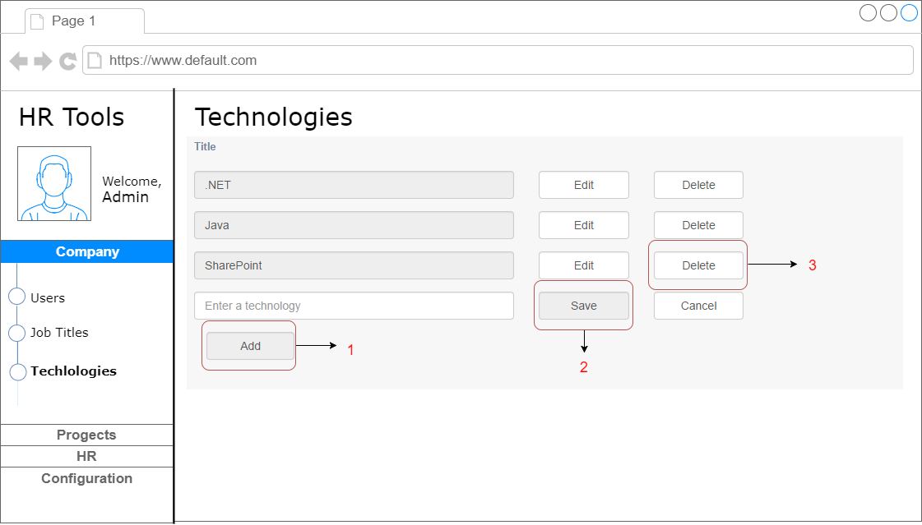

## 2.4. Admin Roles. How to Add User.

Both Admin and Super Admin are able to Add New User.

To add new user - enter 'Company' - > Users.

1. Press 'Add' Button to add new User. To fill in user role - click on appropriate field and select role from drop-down list. Each user must have 'Employee' role assigned.

2. To save - press 'Save', to cancel previous action - press 'Cancel'.

3. To Edit record - press 'Edit'.

4. Also you can Activate or Deactivate User's Account.

5. To Reset password for user, press 'Edit' button first, then press 'Reset Password' button. For password autocomplete - press icon under 'Enter a password' field.

6. For Search function you can use filtering panel.

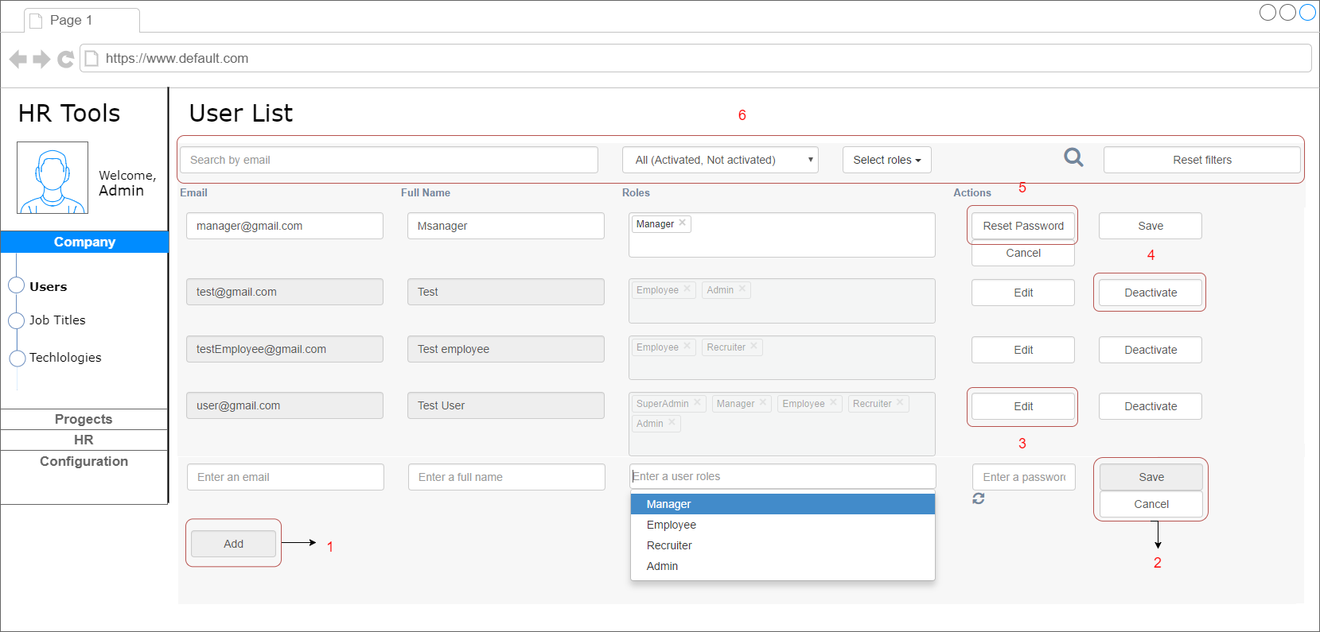

## 2.5. Admin Roles. How to Add Employee

Both Admin and Super Admin are able to Add New Employee.

To add an Employee - enter 'HR' - > Employee.

**Step 1.**

1. Press 'Add' Button to add new Employee.

2. To Edit record- press 'Edit' button.

3. To remove Employee - press 'Delete'.

4. To filter Data - use Filter panel at the top of the page.

5.  How to fill 'Add Employee' form - see **Step 2.**

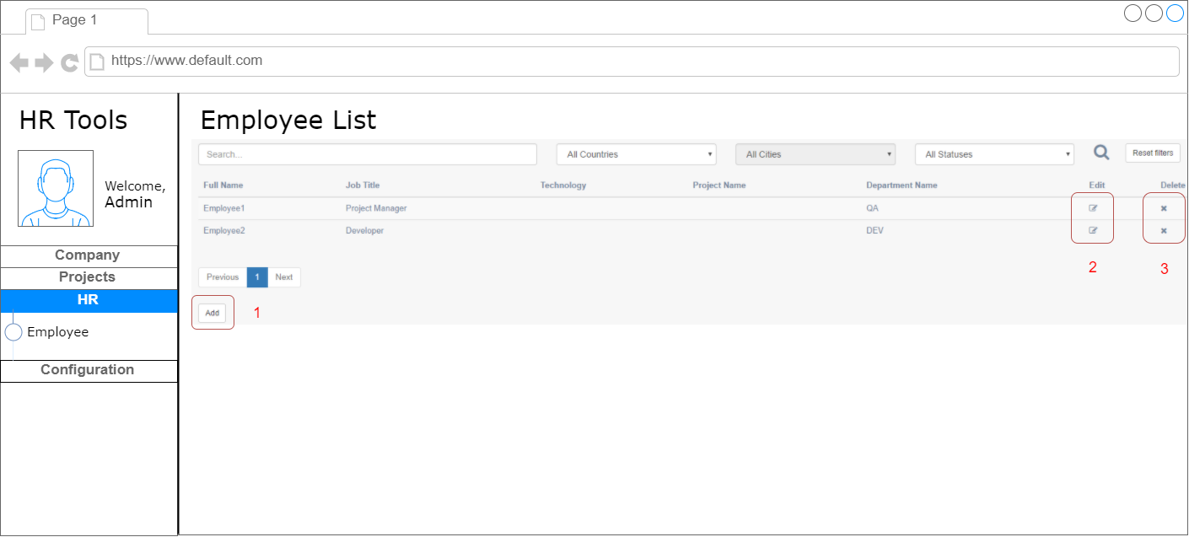

**Step 2.**

1. Fill in all required fields.

2. Select Technology from drop-down list.

3. To fill in Birthday, Start Date and termination Date - use drop-down calendar.

4. To upload Bio - press 'Choose file' Button and select file from PC's directory.

    After file was selected - you can Upload, Cancel or Remove it.

5. To Save - press 'Save' button.

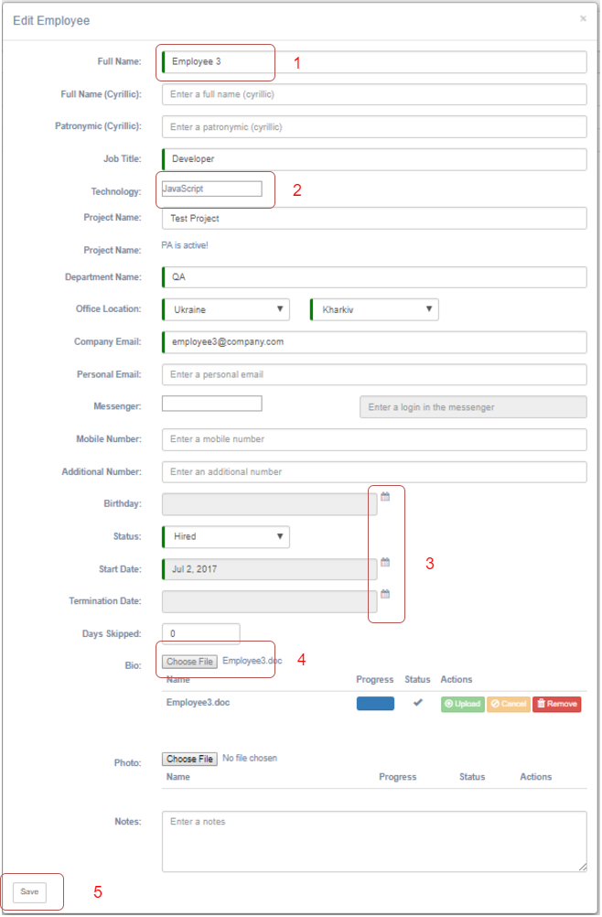

## 2.6. Admin Roles. How to create Projects.

To Create / Edit / Delete Projects you have to be subscribed to this module. To check subscription - enter 'Configuration' section. To add a Project - enter 'Projects' - > sub-menu 'Projects'.

1. Press 'Add' Button to add new Project. Project Name and Start Date are required fields. Project's End Date can’t be less than Start Date. Start Day can't be set for future.

2. To Edit record - press 'Edit' button.

3. To remove Project - press 'Delete'.

4.  Also you can Activate / Deactivate Projects.  To review Deactivated Projects - select 'Show Deactivated' at the Filter's panel.

5.  To Save Project - press 'Save' button.

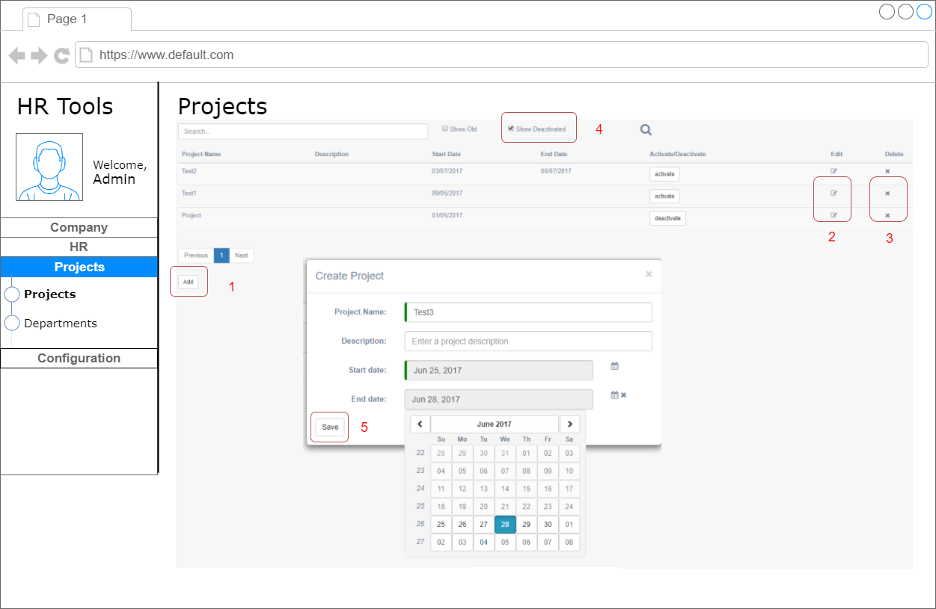

## 2.7. Admin Roles. How to create Department.

To Create / Edit / Delete Departments you have to be subscribed to Project module. To check subscription - enter 'Configuration' section. To add a Department- enter 'Projects' - > sub-menu 'Departments'.

1. Press 'Add' Button to add new Department. Enter Department Name and Description.

2. Then you can Save or Cancel the record.

3. To Edit or Delete Department - press appropriate Button.

4. Also, you can use Search field for quick search.

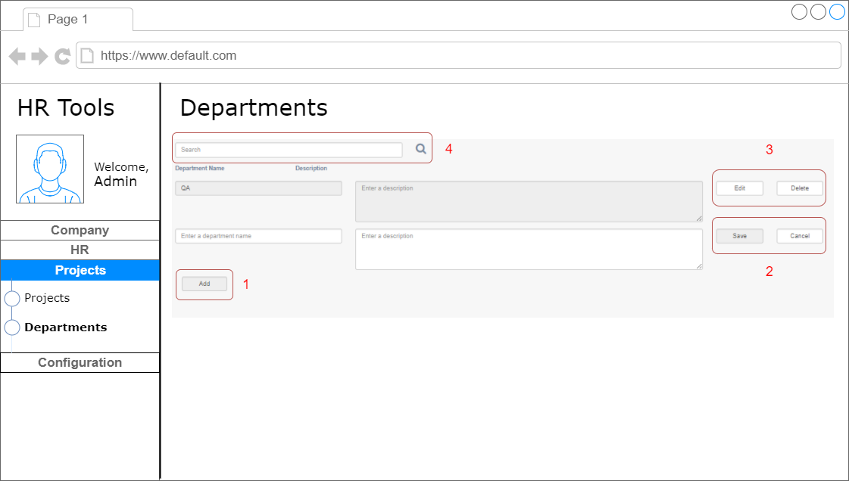

# 3. User Role. Manager.

## 3.1. Public. Assign Employees to Projects/Department.

Only users with access level 'Manager' or 'Admin' are able to assign Employees to Projects.

To Assign Employees to Project use Public interface, enter 'Projects' section - > Project Assignment.

1. Use Filter panel on the top of the page to find Employee, that was assigned before to edit or delete project assignment.

2. Click on 'Assign' Button to Assign new Employee to the Project. Assignment value could not exceed 100%.

3. Fill in required fields, select Project and Department from drop-down list. Note, Start Dare for Assignment shouldn’t be less than Employee Start Date at the Company.

4. To Save - press Save button.

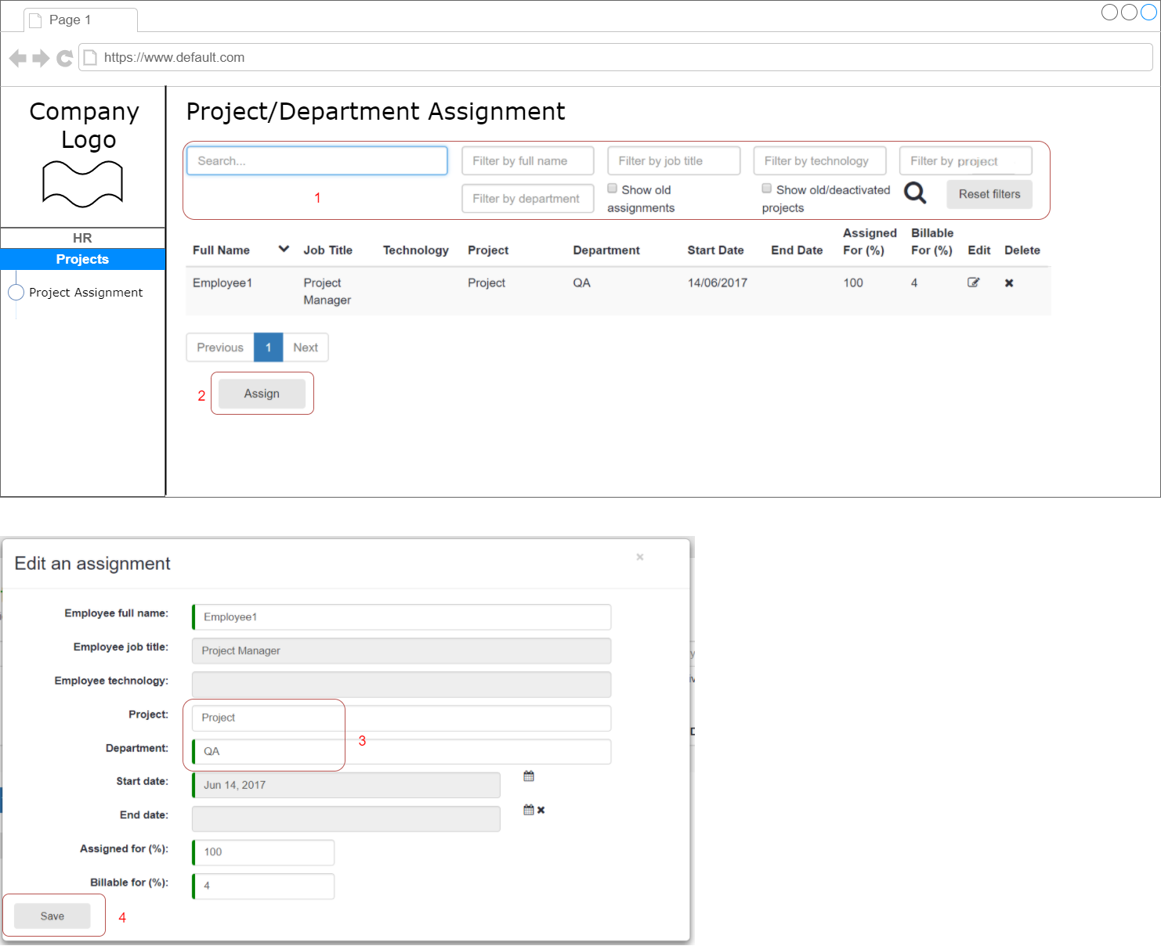

# 4. User Role. Employee.

## 4.1. Public. User Access Level. Employee list.

To Review Company Employee's list, enter 'HR' section - > Employees.

1. Use Filter panel on the top of the page to find Employee.

2. Click on Employee card to review high level information.

3. To review Employee's profile - click on 'Details' Button.

4. To Download Bio - click on appropriate link.

